**Project Report**

Submitted by: Submitted to:

Bhupinder Kaur Simrandeep Kaur

Brahm Aggarwal

Manu Anmol Singh

Martha Marry

Sahar Aghababaei

**Abstract**

***Purpose*:** The purpose of this project is to implement java programming for developing a useful software system which provides value to the society and promotes automation and accessibility.

***Design Methodology:*** The web application is designed with the aid of Java IDE Eclipse and the programming is implemented using object oriented programming, methods, classes, objects, exception handling and wrapper classes.

**Introduction**

Banking is one of the many salient aspects of an individual life. The major objective of this project is to develop a banking/atm machine software which simplifies the banking solutions for clients and businesses. Java programming language is the main fundamental building block of this web application.

**Object Oriented Programming**

An object-oriented programming (OOP) includes using of Classes and Objects to solve a problem. OOP has a number of benefits including security of the data, simplification of the code, reusability of the code (methods). OOP has the following characterstics:

***Class:*** Classes are the fundamental blocks of OOPs. A class consists of structure of particular entity and methods that carries out the processing on the variables of that class.

***Object:*** An object is an instance of the class; Users can create as many objects of the class and each object is distinct from the other object of the same class. For example; Dog is a class which lays out the basic structure (height, weight, name, breed) and each object stores different value of the dog structure (Different values for name, height, weight and breed)

***Abstraction:*** Abstraction is the characteristic which only shows the relevant feature to the client and hides the irrelevant features.

***Encapsulation:*** Encapsulation refers to wrapping everything into a single unit, encapsulation is implemented using the concept of classes where every single attribute (variables) of an entity is packed into a single class.

***Polymorphism:*** Polymorphism refers to using one thing in more than one form. In OOPs polymorphism is implemented using method overloading and method overriding where two methods have the same number but different parameters.

***Inheritance:*** Inheritance is when a child class or a sub class inherits all the public variables and methods of a parent class. This allows the child class to access all the public methods of the parent class.

**ATM Software System**

The atm software system has been implemented using 5 classes; Account class, ATM class, ATM2 class, ATMTest class and WriteFile class. The functions performed by each of the class is defined below:

***Account Class***: Account class consists of the variables that define a particular individual account; Id, Name, Password and Balance. These variables are private and cannot be accessed outside the class, in order to access the outside the class Getter and Setter methods have been defined.

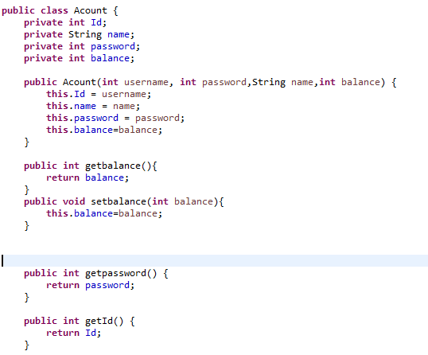

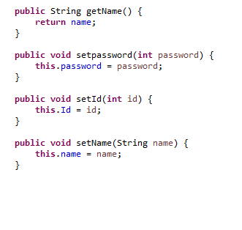

***ATM Class:*** This class includes definition and implementation of all the banking transaction which includes checking if the username is correct, checking if the password entered by the user matches to the respective username, option for viewing balance, option for cash transfer to another bank account (another object), option to withdraw the money from the account and update the account with new balance and option to deposit the money from the account and update the account with new balance.

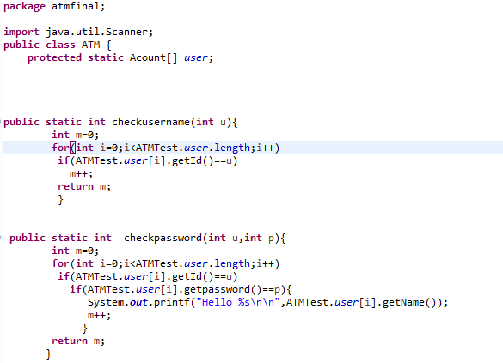

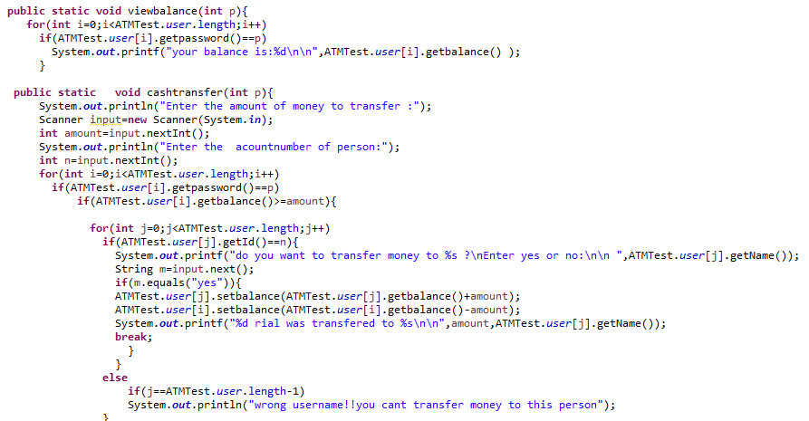

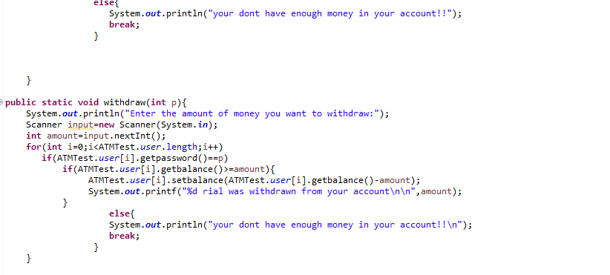

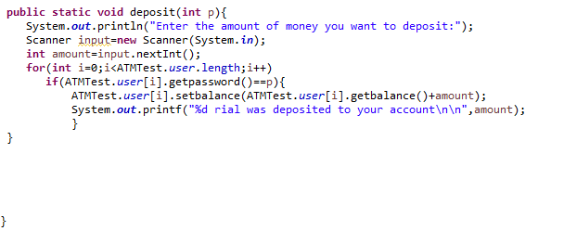

***ATM2 Class:***  This class is responsible for reading and displaying the information of a user present in the text file, it is also responsible for saving the changes made to the file. There is a possibility of Security Exception being throwed in the ‘Account read’ method which has been handled using the try and catch keywords in the method as depicted below:

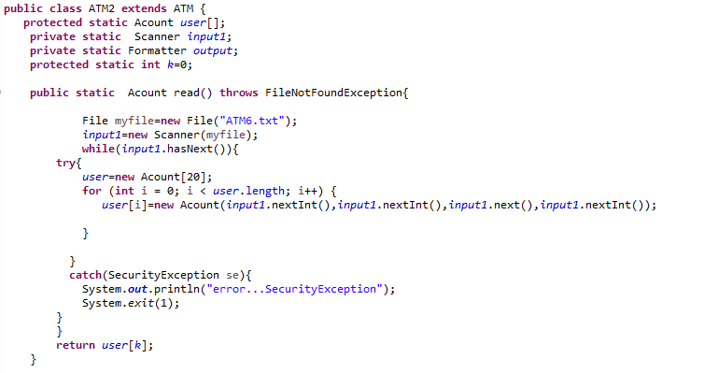

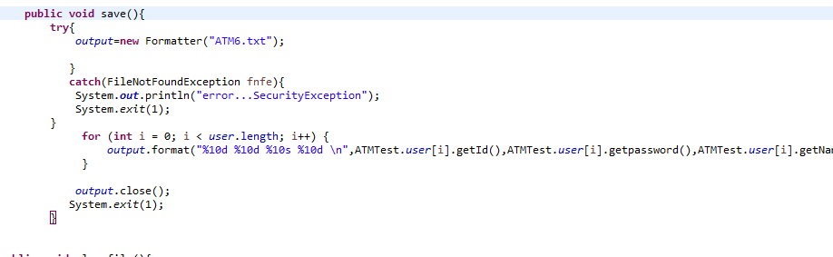

***WriteFile Class:*** This class is responsible for writing the account details of every person into the text file ‘ATM6.txt’ and closing the file after the write operation.

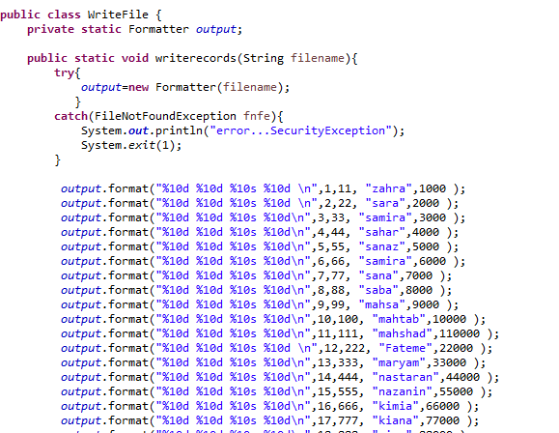

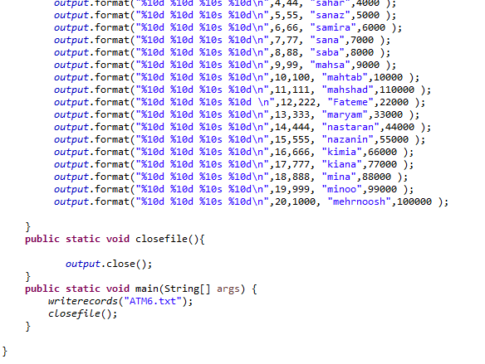

***ATMTest Class:*** This is class where all the methods are being called and tested. This is the final representation of the software system and displays the functionality of the software. Moreover, there is an exception which arises known as ‘InputMismatchException’ this exception occurs whenever the user tries to input a datatype which differs from the original datatype of the variable. This exception has been handled using ‘try and catch’.

